London is the Place For Me (IU English in London, Summer 2024)
Professor Ivan Kreilkamp (Department of English)

May 28 (arrival date)- June 19, 2024
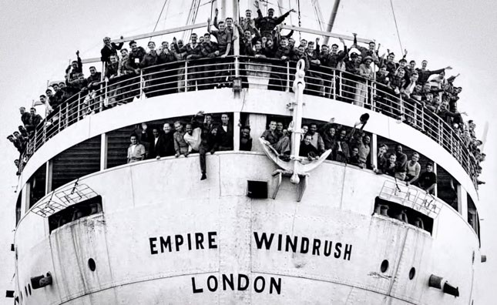
Samuel Johnson famously remarked that when someone “is tired of London, he is tired of life; for there is in London all that life can afford.” London has always struck newcomers as dazzling, magnificent, thrilling, extraordinary; sometimes slightly overwhelming; teeming with an incredibly array of nationalities, ethnicities, and cultures. As we ourselves explore London as visitors and newcomers this summer, we will consider representations of immigration to and arrival in London, from the late 18th to the late 20th century. We’ll be asking such questions as: Who is granted the rights of belonging, to lay claim to Englishness as a Londoner? What were the experiences of journeys from peripheries (both international, e.g. from the Caribbean and West Indies, and national, from rural provinces of England) to metropolitan center? How did the “whiteness” of Englishness transform and mutate, and how did Black Britishness manifest itself and lay claim to national belonging? How were norms of language, art, form and meaning energized and revolutionized by new immigrants to and arrivals in London and England?
How have literature and art defined and explained geographies and spaces of London?
Readings will probably include excerpts from Frances Burney's Evelina, or the History of a Young Lady's Entrance into the World; & from Charles Dickens; then we’ll move to the 20th century with poetry by Claude McKay ("Old England") and Louise Bennett ("Colonization in Reverse" and "Jamaica Language"); calypso music by Lord Kitchener (including his famous "London is the Place for Me," which he sang on the gangplank of the HMS Windrush in 1947 on its arrival in London); dub poetry by Linton Kwesi Johnson (e.g. “Inglan is a bitch”); fiction by Jean Rhys and Sam Selvon; and Andrea Levy’s 2010 novel about Caribbean immigrants to London, Small Island.
Most weekday mornings, we’ll meet for a seminar session to discuss the readings in the Institute for the International Education of Students (IES) in the historic West End; and then we will set out into the city in the afternoon to conduct our own urban investigations. Excursions are likely to include visits to the Museum of London, Docklands; the Migration Museum; Hackney Museum; a walking tour of Brick Lane (a famous street in the East End of London that has been home to generations of different immigrant communities), a visit to the Black Cultural Archives; a visit to Shakespeare’s Globe Theater; and day- long field trips to the Bristol and Liverpool, important cities in the history of migration to England.
This experience will be mind-expanding, intellectually horizon-opening, and so much fun!
Assignments will include shorter reading responses when in London, and a 10-page final paper to be completed shortly after your return to the U.S.
Information on the IES Center: https://www.iesabroad.org/news/cheers-our-new-london-center For any questions, please contact Professor Ivan Kreilkamp: ikreilka@iu.edu

